**Appendix 1.**

PERFORMANCE MONITORING REPORT

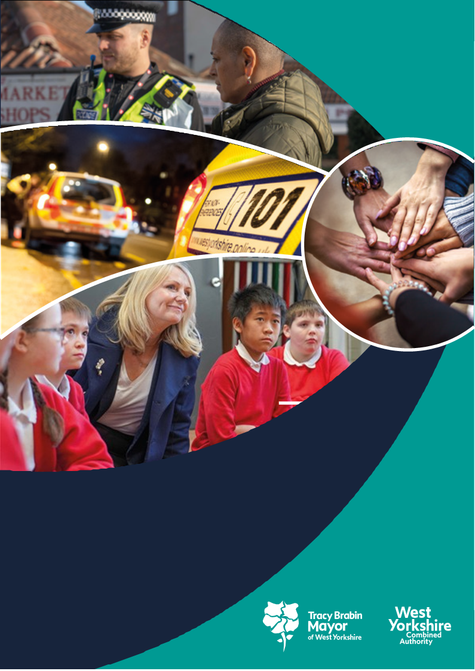

**West Yorkshire:**

**Safe. Just. Inclusive**

**Police and Crime Plan 2021-2024**

**1. Supporting Victims and Witnesses and Improving Criminal Justice Outcomes**



# 2 Figures relate to 2021

# 3 Figures relate to 2022

**1.1 Victim Satisfaction**

1.1.1 The latest victim satisfaction rate stands at 71.5% for the 12 months to Sept 2023. The latest position is 0.4 percentage points higher than 12 months ago.



1.1.2 Performance levels range from 71.9% at Leeds to 76% at Calderdale. Bradford have seen a significant improvement over the last 12 months whereas in contrast Leeds has seen reductions.. The district satisfaction score only looks at crimes dealt with by the district. Those telephone investigations dealt with via the Force Crime Management Unit (FCMU) are not included in the district ratings but are included in the overall West Yorkshire rating.

1.1.3 The biggest reductions in overall satisfaction have been seen for Burglary and Domestic Abuse victims. Victims of Hate and ASB incidents reported the biggest increases in levels of overall satisfaction, both up around 4 percentage points.

1.1.4 Satisfaction for victims of Domestic Abuse is at 83.0%, which is higher than the all crime satisfaction rate of 71.8% (as shown above)

## 1.2 Maintain high levels of calls answered on target.

1.2.1 In the latest 12 months to September 2023 the number of total contacts into West Yorkshire Police have increased by 8.1% (122k additional contacts). During the same period 999s have increased by 4.7% (23k more calls), 101 calls have increased by 5.8% (40k more calls), Other calls have increased by 23.8% (13k more calls) and online contacts have increased significantly by 18.1% (45k more contacts). The very latest quarter is reporting a more stable position with overall contacts increasing by just 0.3% between July-September 2023.



1.2.2 The above trends have had an impact on 999 answering times – the below graph shows the comparison with the MSG. Previously WYP were 5th in the table and are now 2nd.

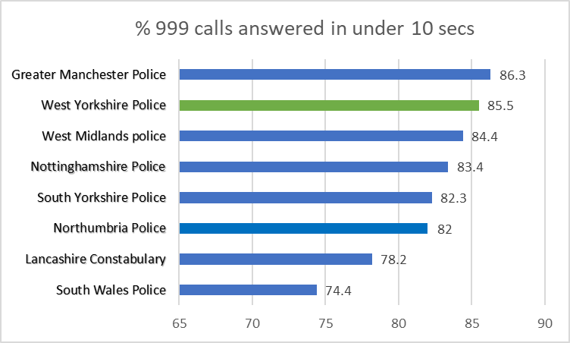

1.2.3 For information – The above is from Police.uk who produce statistics on 999 answering times, but these also include transfer times from BT, which can be 4-6 seconds and can vary across police forces. The comparison data with other forces is available [here](https://www.police.uk/pu/your-area/west-yorkshire-police/performance/999-performance-data/?tc=BDT_BW).

## 1.3 Improve Outcomes

**1.3.1 Rape and Serious Sexual Offences**



1.3.2 The above table shows the position at September 2023 in comparison to the same time last year. The numbers of rape offences are exactly the same as the same time last year, but the outcome rate has increased by 0.5% to 8.2%.

1.3.3 The most recent data that is available nationally is up to August 2023, so not a direct comparison with the above. This data compares forces by looking at crimes per 100,000 population. Previously other areas were not close in number to West Yorkshire, but now we see large increases in some areas which brings them to similar numbers – whereas the affect of CDI is getting slower in WYP



**Serious Sexual Offences**



1.3.4 Serious Sexual offence numbers have increased by 0.2% in comparison with the same time last year, but the positive outcome rate has risen by 1.2% with 100 more victims receiving a positive outcome.



1.3.5 Nationally the Serious Sexual Offence category is not reported on, as this category includes the rape offences above, but there is a category of ‘Other Sexual Offences’ which does not include the Rape offences. In a similar manner to the above Rape offences (with the baseline Jan – Dec 2019) the table below gives an indication of the current position.



Most forces have seen an increase in these crime types and now have similar rates to WYP.

**1.3.6 Domestic Abuse Crime Outcomes**



1.3.7 The above looks at the data for the last 12 months compared to the previous 12 months. The outcome rate has risen by 0.9% and the scale of the work required is shown here as this equates to 359 more victims with a positive outcome.

1.3.8 Nationally only 25 forces report on Domestic Abuse offences in a comparative way. West Yorkshire is one of those forces and this shows that West Yorkshire has the highest numbers of DA offences per 100,000 population. This is due to the high application of CDI, but it is believed that as other forces comply this gap will close.

1.3.9 The above Police outcomes are only part of the picture of support for Domestic Abuse Survivors. This area is being prioritized in Local Criminal Justice Board meetings and continues to be a focus for policing teams.

**1.4 Increase proportion of crimes with victim initial needs assessment**

1.4.1 The Initial Victim Needs Assessment (IVNA) is part of the Victims Code of Practice and is intended to:

1. Determine if the victim needs support.

2. Establish the type of support needed.

3. Assess whether the victim is vulnerable or intimidated.

4. Consider whether the victim is entitled to enhanced rights.

1.4.2 The guidance from the College of Policing shows that obtaining this at initial contact is important to the ongoing investigation, as well as a key consideration towards effective communication and engagement with the victim.

## 1.5 Criminal Justice Measures

1.5.1 It has been agreed that the LCJB will scrutinise a written report on the Delivery Data Dashboards at each Executive Board meeting going forward, providing the dataset has been delivered nationally. These delivery dashboards include the transforming summary justice target data, but also include a number of other data sets. The measures from the Delivery Dashboards give the opportunity to compare current performance with national performance and this report will be able to give these comparisons against the agreed priorities.

1.5.2 The most recent data to the Local Criminal Justice Board Executive board was on 20th September but a full performance report comes every 6 months so there will be a fuller update at the next meeting

**1.5.4 Decrease ineffective trial rate (Magistrates Court)**

1.5.5 The figures here are shown for 2021/22 and then for up to August 2023, This shows a slight increase (3.5%) and is reflective of the increases in the number of trials taken forward.

**1.5.6 Increase volume of early guilty pleas**

1.5.7 The increase of the number of early guilty pleas negates the need for a trial and frees up time which could be used elsewhere.

1.5.8 Again these figures compare the same timescales as the above and this shows an increase in both the Magistrates and Crown Courts.

**1.5.9 Decrease average time taken for cases to be brought to resolution.**

1.5.10 In Q4 it took, on average, 59.2 days from first police referral to CPS making a decision to charge, down 12.8 days in comparison to the same time last year.

**2 KEEPING PEOPLE SAFE AND BUILDING RESILIENCE**

# 

**2.1 Monitor the number of young persons flagged as at risk of Criminal Exploitation**

# 2.1.1 In February 2020 the government produced guidance about the criminal exploitation of children (and vulnerable adults) and as part of this guidance it was noted that *Criminal exploitation of children and vulnerable adults is a geographically widespread form of harm that is a typical feature of county lines activity. It is a harm which is relatively little known about or recognised by those best placed to spot its potential victims.*

# 2.1.2 The purpose of this measure is to gauge how well West Yorkshire Police officers spot this type of exploitation and ensure that these vulnerable victims get the support and help that they need.

# 2.1.3 From the above figures we can see that there is a decrease in numbers and whilst numbers are down in the past 12 months the long term trend is significantly upward..

# 

**2.2 Monitor Indicators from Cyber Dashboard**

# 2.2.1 As Fraud has now been included in the Strategic Policing Requirement, updates about Cyber-crime will now also include updates about action against fraud.

# 2.2.2 The data at Appendix 2 shows the picture for West Yorkshire and includes both Fraud and Cyber offences with a comparison to most similar force areas (MSG).

# 2.2.3 The Economic Crime Unit Team have been involved in a number of initiatives to contribute to Cyber Threat reduction including:

# This year we have run a pilot scheme with Leeds University to collaborate on the best prevent messages to give to students, to protect them from financial harm. Data has highlighted that many students are being targeted by fraudsters, especially international students.

# From 25th to 27th September 2023, our Victim Care and Crime Prevention Officer, Fraud Ambassadors, Cyber Crime Unit, Virgin Money and Crime Prevention Officers were at Leeds University Freshers Week. We engaged with a large footfall of 1,200+ students. Crime Prevention Officers were also providing a bike register service.

# The National Cyber Awards recognise those who work across public, private, and third sectors who are committed to cyber innovation, cyber crime reduction and protecting citizens online. This year's event took place on Monday 25th September and was hosted by BBC Security Correspondent Gordon Corera. The WYP Cyber Crime Detective Sgt was awarded the prestigious Cyber Policing Individual of the Year 2023 title in recognition of her innovative leadership of the Force Cyber Crime Team - a title accompanied by a ‘robot’ trophy, much coveted in the cyber security industry

# The Force Cyber Crime Team were also finalists in the Cyber Policing Team of the Year 2023 category.

**2.3 Repeat Victims of Domestic Abuse and Hate Crimes**

# 

# 2.3.1 Domestic abuse incidents have reduced by 3.6% in comparison to the last 12 months. The repeat victim rate rose by 0.3% in comparison.

# 2.3.2 Following the delivery of the Domestic Abuse Matters training, the Force has now trained 85 Domestic Abuse Champions who will play a key role in recognising and sharing best practice in relation to domestic abuse across the Force.

# 2.3.3 The SCGU continues to issue licences for the online training of the Dr Jane Monckton-Smith eight stage homicide timeline. As of 30th September 2023, 724 officers and staff from across the Force have access to the training modules, with 244 having completed the course..

# 2.3.5 Hate Crime Repeat Victims

# 2.3.6 Hate Incidents have fallen by 12.9% (1,418 fewer incidents) in the latest 12 months to September 2023..

All hate strands have reduced in the past 12 months.

# 2.3.5 Conversely the number of hate crime repeat victims is rising – the increase of 2.9% is a significant increase in comparison to last year, although the current rate is closer to a year ago.

# 2.3.6 When looking at these figures it should be mentioned that the numbers being recorded can be due to many factors, including the effectiveness of the force with regards to Crime Data Integrity (at which West Yorkshire was rated Outstanding), and the willingness of the public to report the offence. What is hidden is the number of incidents that go unreported. The increase in repeat victims could be seen as a positive in that victims are willing to contact the police after reporting a previous offence and shows that this has been a positive experience for them.

# 2.3.7 Almost nine out of 10 hate crimes recorded relate to public order, stalking/harassment and violence without injury. 4.8% of hate incidents in the past 12 months are violence with injury offences and this is 9.7%(52 offences) less than the same time last year.

# 2.4 Increased Use of DVPN and DVPO

# 2.4.1 As discussed in the last Performance Monitoring Report, we can now look at the trends in DVPN and DVPO’s. We will also note the Claire’s laws occurrences as this is another intervention which protects victims of Domestic Abuse. (for more information on Claire’s law please see the WYP website: <https://www.westyorkshire.police.uk/ClaresLaw>

# 2.4.2 After a peak in September 2022, both DVPN and DVPO numbers have been on a falling trajectory although both are higher than the numbers seen in 2021 when HMICFRS highlighted them

# 2.4.3 DVPN and DVPO’s are interventions used after a Domestic Abuse incident has taken place, but Clare’s Law is an early intervention to stop these occurrences taking place and could be argued as a better intervention. The numbers are as follows

**2.5 Use of Stalking Protection Orders (SPOs)**

# 2.5.1 Stalking Protection Orders (SPOs) are being increasingly considered as an option to safeguard victims and manage risks posed by perpetrators. There are currently eight active SPOs, with a further four cases due in court in the next month.

# 2.5.2 The latest victim satisfaction results for the 12 months to August 2023 report overall victim satisfaction (for all crime types) at 68.9% whereas satisfaction reported by stalking victims is higher at 75.8%. 90.2% of stalking victims feel satisfied with how the police have treated them and 78% are satisfied with the outcome.

*.”*

**3 Safer Places and Thriving Communities**

# 

## 3.1 Reduce Homicide

3.1.1 Homicide continues to be a key measure for the Violence Reduction Partnership (VRP), The overall measure shows the current position, but the VRP looks at non-domestic homicide and homicide for under 25s, so the current position for those is shown below.



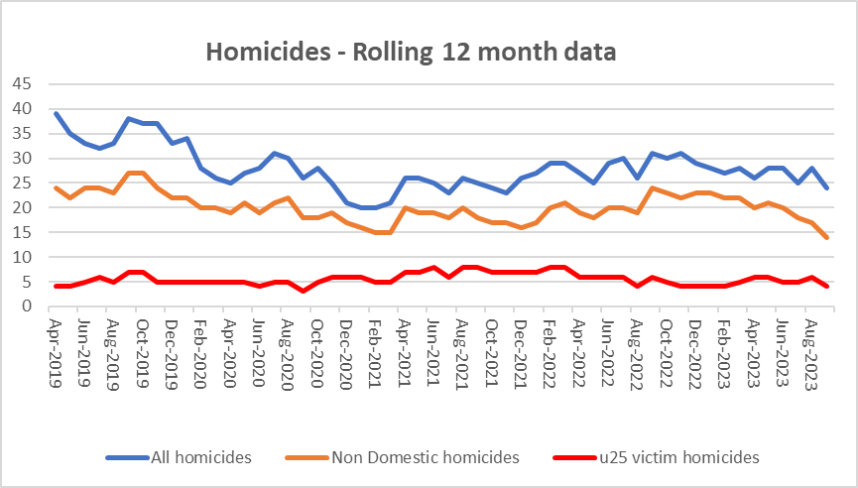

3.1.2 The above data shows the trends for all three crime types for the since 2018. This is now a reduction for all homicides including non-domestic although under 25’s has risen slightly.

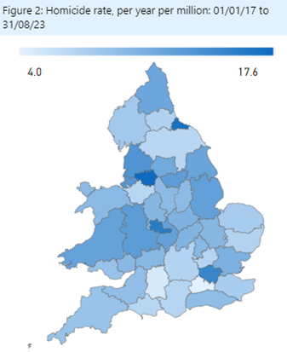3.1.3

The long-term trends for Homicide rates (as shown in the map) evidence that West Yorkshire (11.9 per mil) has a lower rate than many in our MSG including GMP (17.6), West Mids (15.8) and South Yorkshire (12.4)

**3.2 Reduce all hospital admissions for assault with a sharp instrument.**

3.2.1 Hospital admissions are up to June 2023 and show a decrease for both groups



**3.3 Reduce Knife Crime**

3.3.1 The undulating picture with knife crime can be seen in the below graph. There was a reduction during the pandemic and then a rise back to normal levels which reached its peak a year ago. This then decreased again, but the since the beginning of the year there has been an increase in knife crime and figures are now above the same time last year. The most recent two months have seen a slight increase in these crimes. These are still well below the baseline figures

3.3.2 The most recent update nationally is to June 2023 – The below table looks at knife crime per million residents when compared to the Jan-Dec 2019 baseline. The below table compares with others in our most similar group.



3.3.3 It should be noted that West Yorkshire Police is one of 40 forces which uses a national methodology for recording knife crime. The remaining forces will be using the same methodology soon, but until then, national comparisons are problematic. Also data for West Midlands is provisional due to a move to a new computer system.

**3.4 Reduce number of ASB incidents.**

3.4.1 ASB incidents have fallen by -8.3% (-2,449 incidents) when comparing the latest 12 months to September 2023 with the previous 12-month period.

3.4.2 The fall in ASB is significantly impacted by crime recording improvement activity. HMICFRS crime recording inspections across a number of Forces has highlighted that some ASB logs (and particularly ASB personal logs) should be considered for a crime being recorded. The chart below shows this change



3.4.3 The left-hand graph shows the rolling 12 monthly trend for ASB incidents. Due to training within contact at West Yorkshire Police, the logs that would have previously been in coded as ASB are now immediately flagged as a crime and this is reflected (right graph) by the blue line in comparison to orange line which shows the in-codes for the crimes.

**3.5 Keep Neighbourhood Crime below baseline.**

3.5.1 In previous iterations of this document we have looked at the baseline of June 2019. More recent iterations of figures from the government look at this baseline as the 12 months to December 2019, so we have now changed to fall into line with this comparison

3.5.2 Figures for 2022/23 report that Neighbourhood Crime offences have fallen by 35.4% when compared to the 12 mths to Dec 2019 baseline equating to nearly 12.000 fewer victims. Notable reductions are residential burglary (down 35.7%), theft from person (down 17.4%), and theft from vehicle (down 41%).

3.5.2 The below table looks at these crime types to break down the overall figures.



3.5.3 The one area that is different is Theft Of Motor Vehicle. This crime type continues to be the only one that is above the 12months to June 2019 baseline.

3.5.6 Compared with our most similar group, West Yorkshire has one of the largest % change in comparison to the baseline.(offences per 100,000 population).



**3.6 Monitor cyber-attacks on businesses via WYCA survey**

3.6.1 This data is not available currently.

**3.7 Increase proportion of workforce from ethnic minorities**

3.7.1 Overall the proportion of the total WYP workforce from ethnic minorities is at 8.1% but officers are currently above this at 9.1%. Although staff numbers are lower at 6.2% this is still an increasing trend.

3.7.2 As reported nationally, West Yorkshire Police exceeded its target for recruitment of officers and although the overall proportion of officers and staff from ethnic minorities continues to be below that of the West Yorkshire population, during recruitment this proportion was much higher and nearer to the target.

**3.8 Increase proportion of female officers**

3.8.1 West Yorkshire continues with high numbers of female officers - the following looks at both ethnic minorities and female workforce national comparisons.

3.8.2 Police workforce Statistics are available on the Gov.uk website – the most recent are to March 2023.

At this point there were 2,328 FTE female officers in West Yorkshire which is 38.3% of the workforce. West Yorkshire has the 7th largest percentage across all the 43 territorial forces in England and Wales and the 2nd largest in our group of most similar forces. Of these female officers 5.7% are from Ethnic minorities.

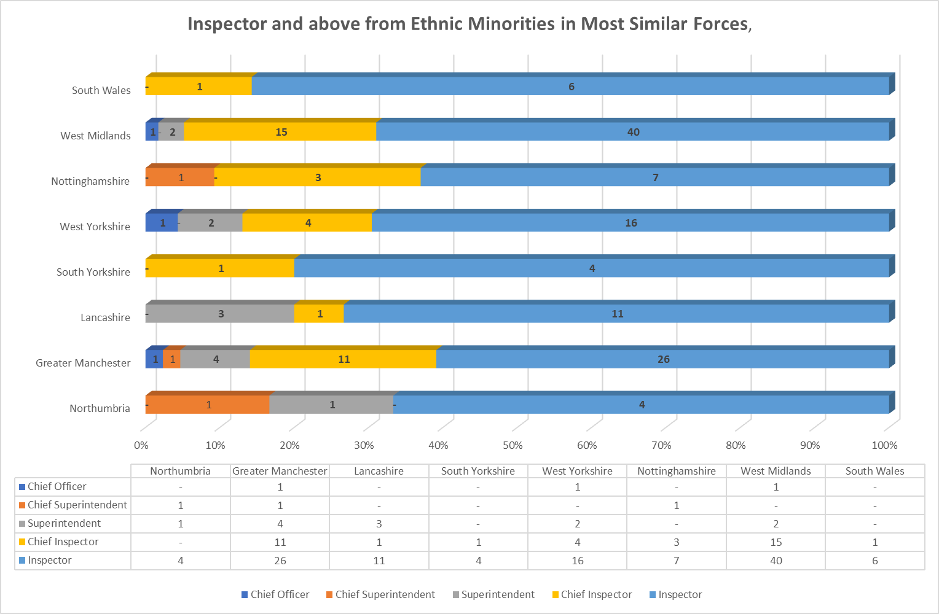

**3.9 Reduce numbers of KSIs on roads in West Yorkshire**

3.9.1 Numbers of KSIs on the roads in West Yorkshire is currently increasing and this is the focus of the Vision Zero meetings in West Yorkshire

3.9.2 From a Road Safety perspective, West Yorkshire operates a partnership approach to reduce KSI’s with an overall aim of Vision Zero by 2040. The partnership sees the Combined Authority and West Yorkshire Police working with all five district authorities, West Yorkshire Fire and Rescue Service and National Highways. The partnership supports West Yorkshire Police enforcement operations and provides some funding to support initiatives

3.9.3 The office held a recent Vision Zero conference where the Vision Zero strategy was agreed with all parties. This is being driven by the Vision Zero board which is chaired by the Deputy Mayor.

**3.10 Increase number of additional officers and staff in comparison to April 2021 baseline**

3.10.1 The numbers here show that officer numbers are increasing as expected, with staff numbers also increasing even with the current budget constraints.

3.10.2 The Mayor and Deputy Mayor receive a quarterly update for this measure to ensure that the Mayoral Pledge is met. This paper discusses the current situation and where there are any risks. Currently the projections are showing to surpass the pledge by the end of the Mayoral term for officers.

**4. Responding to Multiple and Complex Needs**



**4.1.1 Monitor VRU early intervention programme attendee figures**

4.1.2 As part of its monitoring information for the Home Office, the Violence Reduction Partnership must show the impact of its work by counting the number of young people (and others) that it reaches.

4.1.3 The VRP sends these figures quarterly to the Home office to show the impact of its interventions. These interventions have been detailed in previous papers to the panel and will continue to be part of the impact of the Police and Crime plan.

**4.2 Reduce number of repeat missing persons.**

4.2.1 Number of Missing persons per 1000 population

Over the last 12 months there have been 10,877 missing persons (including repeats). The trends for this are as follows.

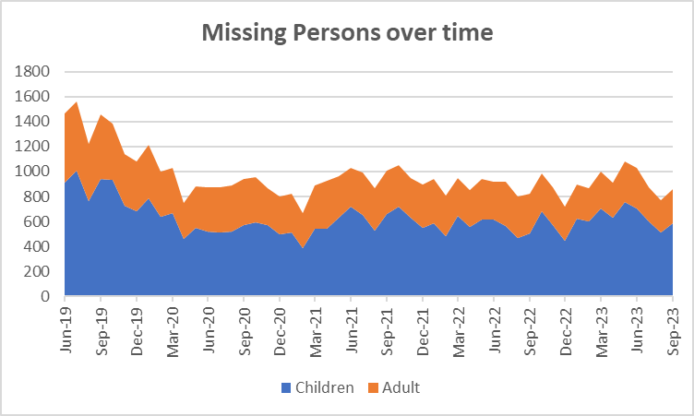

4.2.2 The number of missing children in comparison to adults has been stable over time even with the reductions seen during the pandemic, but recently there has been an increase in the ratio of children to adults (as seen at the top of the table below)

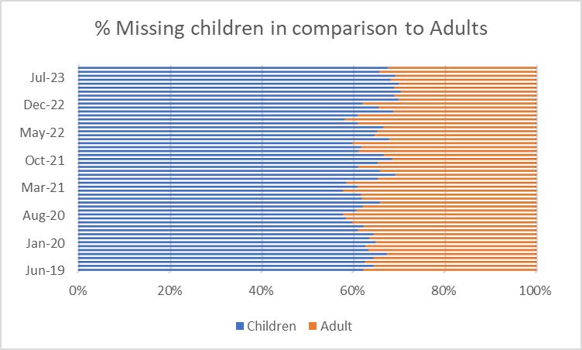

4.2.3 The next table looks at the numbers of repeat missing occurrences.

4.2.5 The number of repeat missing persons is detailed above. This stands at 37.2% for missing children and 12.2% for missing adults.

4.2.2 Although the numbers are slightly lower, the extent of the work can be seen above with 18 missing children having greater than 30 occurrences throughout the year. This continues to be a drain on police resources.

**4.3. Reduce Re-offending Rate for Drug Related Crime**

4.3.1 Due to the time lapse required to ensure offences are taken into consideration, the re-offending rates are for offenders who were convicted 12 months ago.

4.3.2 The current figures show that there has been a 1.0% reduction in this rate in comparison to the same time 12 months ago.

4.3.3 Work is ongoing with the Senior Responsible Officers for the Combatting Drugs WY partnership with the Deputy Mayor bringing all 5 districts together to discuss common problems and share best practice.

4.3.4 West Yorkshire Reducing Reoffending Partnership Board: This is the current iteration of the board convened by the Mayor and chaired initially by the Criminal Justice Policy Manager. The intention of this board is to add value to existing Reducing Reoffending Partnerships within districts and their work with Criminal Justice partners including Youth Justice.

**4.4 Reduce the number of First-time entrants to the CJS**

4.4.1 There is a bit of a time lapse with this measure with this measure, as we rely on the Ministry of Justice data which is based on offenders on PNC as having their 1st conviction, caution or youth caution. This now compares 12 months to Sept 2021 to 12 months to Sept 22 (which is the latest data available).

4.4.2 Both Adult and youth offenders are seeing a decrease in this measure currently.

**4.5 Increase number of offenders referred to drug treatment services via Liaison and Diversion**

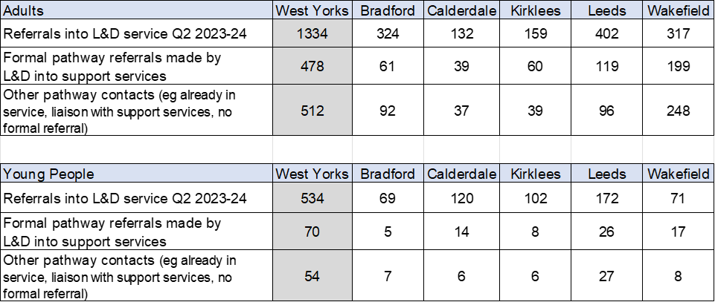

4.5.1 Figures relate to referrals to drug services across the five districts. Figures provided by West Yorkshire All Age Liaison and Diversion Service.

4.5.2 The figures relate to the most recent quarter (July – Sept)

4.5.4 These statistics and the work undertaken are discussed on the Liaison and Diversion Strategic Board – this is attended by the DMPC on a regular basis.

4.5.5 The most recent executive board for Liaison and Diversion noted that views had been canvassed from courts in West Yorkshire and the feedback was very positive with such comments as ‘don’t let it stop’. It is appreciated in all courts in West Yorkshire

4.5.6 Referrals are up for both adults and young people, but there has been a reduction in formal pathway referrals and also other pathway contacts. Areas are looking at other pathway contacts to enhance this data from partners.

Appendix 2

**Cyber Crime**

**Reports, referrals, and outcomes for**

The below data is for Oct 22 to Sept 23

Cyber Crime reporting

The above is for Cyber Crime only the picture for Fraud is as follows.

For business Cyber Crime **only** the current picture is as follows:

|  |  |
| --- | --- |
| **Acquisitive crime** | Acquisitive crime is defined as an offence where the offender derives material gain from the crime. Examples include shoplifting, burglary, theft, and robbery. |
| **BAME** | BAME stands for Black, Asian and Minority Ethnic and is used to describe people from any of these ethnicities. |
| **Child sexual exploitation and abuse** | Sexual exploitation of children and young people under 18 involves exploitative situations, contexts, and relationships where young people (or a third person or persons) receive 'something' (e.g., food, accommodation, drugs, alcohol, cigarettes, affection, gifts, money) because of them performing, and/or another or others performing on them, sexual activities. |
| **Community Safety Partner** | Several different organisations have a role to play including local councils, fire and rescue service, health and probation services and housing providers etc. These are often referred to as local community safety partners. |
| **Conviction rate** | This measure is calculated by dividing the number of defendants convicted by the total number of defendants prosecuted in the court during the period in question. The total number of defendants prosecuted in the court includes those charged by the police and Crown Prosecution Service but whose cases were dropped. |
| **Crime rate** | The crime rate used in this document refers to the number of offences committed per 1000 people in the population. |
| **Cyber crime** | Can be seen in two parts: cyber-enabled crime, where crimes that may be committed without computers are instead committed using computer networks (for example fraud and bullying); and pure cyber-crime where the offence can only be committed using computers (for example computer hacking or use of malicious software). |
| **GAP**  **Human trafficking** | Anticipated Guilty Plea  Human trafficking is the trade of humans, most commonly for the purpose of forced labour or commercial sexual exploitation by the trafficker or others. |
| **IOM** | Integrated Offender Management (IOM) is an overarching framework that allows local and partner agencies to come together to ensure that the offenders whose crimes cause most damage and harm locally are managed in a coordinated way. |
| **Ineffective trial** | An ineffective trial occurs when the trial does not go ahead on the date planned due to action or inaction by one or more of the prosecution, the defence or the court and a further listing for a trial is required. |
| **Most similar police groups/family/forces**  **NGAP** | Most Similar Groups (MSGs) are groups of police force areas that have been found to be the like each other based on an analysis of demographic, social and economic characteristics which relate to crime. Each police area has its own group of up to seven police areas to which it is ‘most similar’. MSGs are designed to help make fair and meaningful comparisons between police areas which share similar characteristics, rather than, for example, comparisons with a neighbouring police area.  Anticipated Not Guilty Plea |
| **Operational functions** | Operational functions include things like patrolling neighbourhoods, responding to 999 calls, roads policing and protecting vulnerable people. |
| **Outcomes/detections** | Outcomes/detections are used by the Home Office to describe the result of a police investigation following the recording of a crime. They can include cautions, charges, fixed penalty notices, cannabis warnings etc. There are 21 categories of outcomes. |
| **PEEL**  **Positive Outcomes** | HMICFRS carry out several thematic annual inspections throughout the year, these are drawn together into a wider PEEL assessment which stands for Police Effectiveness, Efficiency and Legitimacy. The aim of the PEEL assessment is to judge each police force in a cross-topic way based on criteria which consider the full breadth and complexity of what the police do.  Outcomes which fall into the first 8 categories for Police outcomes, these include mostly charges, cautions and community resolutions. |

**Find out more.**

westyorks-ca.gov.uk

@WestYorkshireCA

enquiries@westyorks-ca.gov.uk

+44 (0)113 251 7272

All information correct at time of print (March 24)