Serious Violence Strategic Needs Assessment

January 2024
Authored by the Violence Reduction Partnership

Contents
Foreword 3
Introduction 4
Definition of violence 4
Cost of violence 5
Performance 6
Bradford 11
Calderdale 12
Kirklees 13
Leeds 14
Wakefield 15
Community Voice 16
Influential factors 17
Key Findings 18

Foreword

Tackling serious violence remains high on both the national and local agenda, with media headlines often demonstrating the devastating costs to communities.

Our Strategic Needs Assessment 24/25 comes at a critical time for West Yorkshire, enabling us to meet the challenges with informed solutions, striking at the heart of the issues.

All the knowledge, learning and experience we have gathered over the years has been concentrated to develop this latest document, which takes us another step forward in our joint ambitions.

Having recently become the West Yorkshire Violence Reduction ‘Partnership’ our understanding is expanding exponentially, and this is informing our approach.

Recognising the ways in which serious violence manifests itself and changes, is crucial to determining how we respond and adapt.

This means unpicking the data, speaking to our partners and those with lived experience.

It allows us to make an accurate assessment of community needs and identify the right remedies for the right places, at the right times.

With the introduction of the ‘Serious Violence Duty’, placing legal requirements on certain agencies, we are in a stronger position than ever before.
This local investment into preventing and reducing serious violence, can only take us forward in our collective aim of keeping West Yorkshire safe, just, and inclusive.

Director of the West Yorkshire Violence Reduction Partnership
Detective Chief Superintendent, Lee Berry

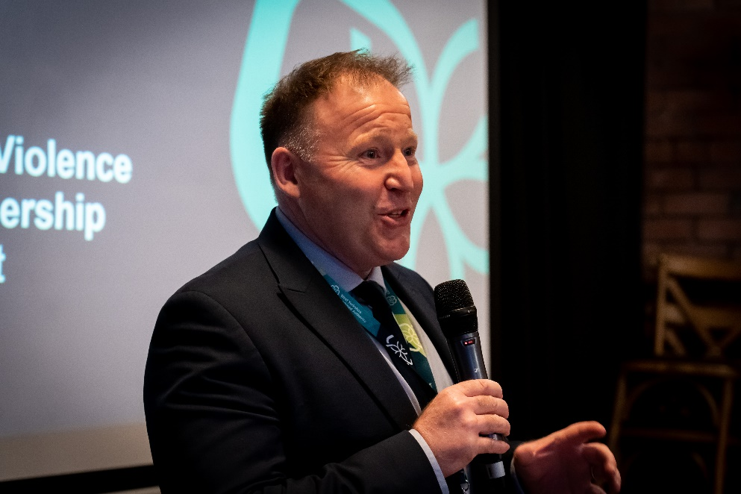

Introduction
This West Yorkshire strategic needs assessment (SNA) provides a refreshed baseline and shared understanding of the reality of violence in West Yorkshire through the analysis of a comprehensive suite of local and national data. Central to this understanding is:
- What is the shape of the problem;
- Where is it taking place;
- When is it taking place;
- Who is involved; and,
- Why is it happening.
Setting out our understanding of the problem of violence in this way is critical to the success of the West Yorkshire Violence Reduction Partnership and our partners.
The Police, Crime, Sentencing and Courts Act 2022 outlines new duties in respect to serious violence. This specific new Serious Violence Duty (SVD) requires specified authorities, known as duty holders, to work together to prevent and reduce serious violence.
To support duty holders, we have developed five district level profiles to identify localised issues. We have provided the key findings from each of these profiles within this document. The findings of this SNA and respective district level profiles should be used to assist named duty holders with preparing and delivering a needs-focused action plan to reduce serious violence as required by the SVD.
The information presented has been provided through effective data sharing practices by partner agencies, to which we are grateful, as tackling serious violence requires a collective and partnership driven response.

The document should be read in conjunction with the influential factors evidence synthesis.

Definition of violence
The Home Office outlined three key success measures for VRPs:
- A reduction in hospital admissions for assaults with a knife or sharp object and especially among those victims aged under 25.
- A reduction in knife-enabled serious violence and especially among those victims aged under 25.
- A reduction in all non-domestic homicides and especially among those victims aged under 25 involving knives.

Beyond these three success measures, the Home Office allowed for flexibility for VRPs to adopt a broader definition of serious violence. As a partnership, we developed a broader, vision, definition and framework of success measures which also allows a response to the Serious Violence Duty:

“Violence and serious violence includes specific crime types where there is the use of physical force or power, threatened or actual, against oneself, another person, or against a group or community”.

The specific crime types included in this SNA include robbery, homicide, knife crime and assault to cause serious harm.

Cost of violence
The costs of each serious violence offence type in West Yorkshire has been estimated by multiplying the number of recorded crimes between July 2022 and June 2023 by the unit cost of crime provided by the Home Office.

These unit costs have been adjusted to factor in inflation rates since the publication of the original costs in 2018. Please note this figure of inflation is an estimate that has been calculated using the Bank of England Inflation Calculator.

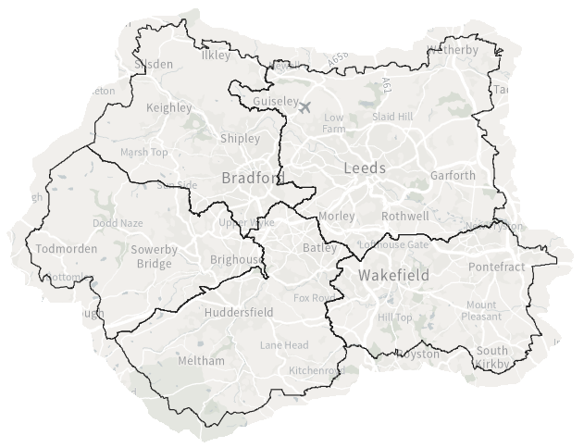

The overall estimated cost for Serious Violence in West Yorkshire is £1,307,944,366
Homicide | £118,151,768
Other Sexual Offences | £50,147,216
Rape | £182,360,176
Robbery | £46,820,846
Violence with Injury | £533,403,750
Violence without Injury | £377,060,610
Table 1 - Overall Estimated Cost for Serious Violence in West Yorkshire

Performance
The Violence Reduction Partnership are measured against three core measures by the Home Office;
  - A reduction in hospital admissions for assaults with a knife or sharp object and especially among those victims aged under 25,
  - A reduction in knife-enabled serious violence and especially among those victims aged under 25,
  - A reduction in all non-domestic homicides and especially among those victims aged under 25 involving knives.
Compared to 2018/19 levels (prior to VRP funding) we have seen a reduction in all but one of the measures – Knife enabled serious violence against those under 25 fell by 14.2% with the change in the last 12 months continuing to show a reducing trend. Hospital admissions for assaults by a sharp object (again, against those under 25) also reduced overall by 6.7% since funding began, with the most recent 12-month period bringing us back down from increased admission rates in 2021.

Whilst non-domestic homicides overall have reduced since funding began, there was a reduction in victims over 25 paired with an increase in victims under 25. This core measure shows a 33% increase but when looking at numbers this is an increase from 3 to 4.

Crime Measures | 2018/19 | 2021/22 | 2022/23 | Change on last year | Change on 2018/19
Knife-enabled serious violence | 2595 | 2342 | 2297 | -1.9% | -11.5%
with victim aged under 25 | 982 | 858 | 843 | -1.8% | -14.2%
Non-domestic homicides | 25 | 18 | 20 | 11.1% | -20.0%
knife-enabled with victim under 25 | 3 | 3 | 4 | 33.3% | 33.3%
Hospital Admissions for assaults by a sharp object (ages 0<25)
 | 2019 | 2020 | 2021 | 2022 | Change on last year | Change on 2019
West Yorkshire Hospitals | 75 | 80 | 90 | 70 | -22.2% | -6.7%
Leeds Teaching Hospitals NHS Trust | 45 | 45 | 50 | 45 | Please note, hospital admissions data has been rounded to the nearest 5 and is shown for all West Yorkshire hospitals – the adjacent table shows the proportion of the total for each Trust but is based on rounded numbers.
Mid Yorkshire Teaching NHS Trust | 10 | 15 | 10 | 10
Bradford Teaching Hospitals NHS Foundation Trust | 10 | 10 | 10 | 10
Calderdale & Huddersfield NHS Foundation Trust | 5 | 0 | 5 | 5
Airedale NHS Foundation Trust | 0 | 0 | 0 | 0
Table 2 - Home Office measures
An overview of all violent crime can be found in the following table, which shows a breakdown of violent crime in the 12 months ending June 2023, and how those numbers compare to both the previous year and the last year prior to the COVID-19 pandemic.
Offences | Recorded crime  Jul-22 to Jun-23 | Per 1,000 population | Non-recent | DA | Victim under 25 | Victim under 18 | Knife enabled | Public space | Recorded crime change on previous 12 months | Recorded crime change on 2018/19
Violence against the person | 132,474 | 56.33 | 5.7% | 37.1% | 29.9% | 16.0% | 1.1% | 31.9% | 2.6% | 22.3%
Homicide | 28 | 0.01 | 3.6% | 28.6% | 21.4% | 17.9% | 46.4% | 50.0% | 7.7% | 0.0%
Violence with injury | 28,950 | 12.31 | 3.8% | 37.0% | 32.9% | 18.0% | 3.7% | 46.7% | -2.1% | 1.2%
Attempted murder | 34 | 0.01 | 2.9% | 20.6% | 38.2% | 35.3% | 55.9% | 42.9% | -26.1% | 3.0%
Assault with intent to cause serious harm | 2,007 | 0.85 | 3.7% | 25.3% | 29.5% | 12.8% | 22.9% | 58.4% | 0.7% | 4.2%
Violence without injury | 48,487 | 20.62 | 3.4% | 33.6% | 33.4% | 21.3% | 0.9% | 39.1% | 5.4% | 14.6%
Stalking and harassment | 54,928 | 23.36 | 8.8% | 40.4% | 25.4% | 10.3% | 0.0% | 16.1% | 2.6% | 47.1%
Robbery | 3,154 | 1.34 | 0.8% | 3.6% | 40.9% | 23.4% | 24.9% | 83.8% | 14.1% | -19.0%
Robbery of business property | 373 | 0.16 | 0.5% | 0.3% | 13.4% | 0.3% | 28.4% | 96.1% | 18.8% | -17.5%
Robbery of personal property | 2,781 | 1.18 | 0.8% | 4.0% | 44.6% | 26.5% | 24.4% | 82.1% | 13.5% | -19.2%
Sexual offences | 9,398 | 4.00 | 24.5% | 20.7% | 64.4% | 49.8% | 0.4% | 26.6% | 0.8% | 9.3%
Rape | 3,533 | 1.50 | 35.9% | 39.7% | 56.1% | 36.5% | 0.8% | 16.7% | -2.8% | 2.7%
Other sexual offences | 5,865 | 2.49 | 17.6% | 9.2% | 69.4% | 57.9% | 0.2% | 32.3% | 3.0% | 13.8%
Arson | 1,553 | 0.66 | 0.5% | 4.6% | 6.9% | 0.4% | 0.0% | 57.2% | 6.4% | -13.7%
Arson endangering life | 191 | 0.08 | 0.5% | 12.0% | 7.3% | 1.0% | 0.0% | 16.1% | -6.4% | -22.0%
Possession of weapons | 2,475 | 1.05 | 1.3% | 2.7% | 10.8% | 6.6% | 0.2% | 69.8% | -1.4% | 5.3%
Knife crime | 2,321 | 0.99 | 2.3% | 27.1% | 36.5% | 19.0% | 100.0% | 53.3% | -1.7% | -11.0%
Robbery of business property | 106 | 0.05 | 0.0% | 0.0% | 18.9% | 0.0% | 100.0% | 96.2% | -4.5% | -39.4%
Robbery of personal property | 679 | 0.29 | 1.2% | 2.7% | 54.6% | 32.3% | 100.0% | 79.2% | 17.7% | -12.9%
Homicide | 13 | 0.01 | 0.0% | 15.4% | 30.8% | 23.1% | 100.0% | 50.0% | 85.7% | 62.5%
Attempted murder | 19 | 0.01 | 0.0% | 5.3% | 63.2% | 57.9% | 100.0% | 60.0% | 58.3% | 111.1%
Assault with intent to cause serious harm | 459 | 0.20 | 3.1% | 23.5% | 33.3% | 14.8% | 100.0% | 54.1% | -10.0% | -14.8%
Assault with injury | 562 | 0.24 | 3.6% | 48.2% | 30.4% | 16.0% | 100.0% | 29.0% | -14.2% | -2.3%
Threats to kill | 402 | 0.17 | 2.7% | 52.0% | 24.4% | 10.4% | 100.0% | 21.7% | -3.4% | -9.3%
Firearms crime (serious violence) | 687 | 0.29 | 0.9% | 3.1% | 40.0% | 20.7% | 0.0% | 86.9% | 189.9% | 132.1%
Serious violence | 7,339 | 3.12 | 2.5% | 16.7% | 34.2% | 17.8% | 31.3% | 68.0% | 13.0% | -2.2%
Table 3 - Overview of All Violent Crime

The last year saw a small increase in the numbers of violence against the person offences (2.6%), but this was a 22% increase on the 2018/19 baseline.

This increase is largely due to increases in offences of stalking and harassment – up 47.1%, violence without injury – up 14.6%, and sexual offences – up 9.3% on 2018/19.

Robbery increased in the last year (14.1%) but remains at lower levels than 2018/19. Where a knife was used during the commission of a robbery, this was down on 2018/19 figures for both business and personal robbery offences.

Overall knife crime is lower than last year (-1.7%) and 2018/19 (-11%), but small increase in the numbers of knife-enabled homicide and attempted murder offences have resulted in large percentage increases in these most serious violent crimes.

The numbers of firearms and serious violence offences were adversely affected by the gel gun social media trend in June 2023, although serious violence is still at lower levels than 2018/19. Since the data was analysed for this profile, West Yorkshire Police confirmed that the data has been reworked and this specific type of incident has been removed from firearms crime numbers.

There are known data quality issues relating to ‘location qualifiers’ used to denote the type of place an offence took place at, as such caution should be applied to conclusions drawn from the public space flagging.

Whilst the Home Office core measures look to those under 25, we have separately explored violence against children (those under 18) and noted an increasing trend – the following table shows a breakdown in offences with a victim who was aged under 18.

Violence against children offences | Recorded crime Jul-22 to Jun-23 | Non-recent | DA | Knife enabled | Public space | Recorded crime change on previous 12 months | Recorded crime change on 2018/19
Violence against the person | 21,213 | 7.6% | 11.2% | 1.0% | 34.4% | 16.2% | 33.9%
Homicide | 5 | 0.0% | 0.0% | 60.0% | 33.3% | 400.0% | 150.0%
Violence with injury | 5,225 | 4.9% | 10.6% | 3.2% | 54.3% | -1.5% | -1.7%
Attempted murder | 12 | 8.3% | 0.0% | 91.7% | 50.0% | 71.4% | 140.0%
Assault with intent to cause serious harm | 256 | 7.8% | 3.3% | 26.6% | 66.5% | 15.8% | 19.6%
Violence without injury | 10,329 | 8.5% | 8.8% | 0.4% | 33.4% | 26.4% | 50.9%
Stalking and harassment | 5,648 | 8.5% | 16.0% | 0.0% | 14.9% | 18.1% | 53.3%
Robbery | 738 | 0.5% | 0.5% | 29.7% | 95.3% | 41.1% | 13.2%
Robbery of business property | 1 | 0.0% | 0.0% | 0.0% | 100.0% | -50.0% | -50.0%
Robbery of personal property | 737 | 0.5% | 1.0% | 29.7% | 95.3% | 41.5% | 13.4%
Sexual offences | 4684 | 32.0% | 6.9% | 0.1% | 22.0% | 1.8% | 2.7%
Rape | 1288 | 53.8% | 15.7% | 0.3% | 21.3% | -6.6% | -11.6%
Other sexual offences | 3396 | 23.7% | 3.5% | 0.0% | 22.3% | 5.4% | 9.5%
Arson | 6 | 0.0% | 16.7% | 0.0% | 66.7% | -60.0% | -53.8%
Arson endangering life | 2 | 0.0% | 0.0% | 0.0% | 0.0% | -50.0% | -66.7%
Possession of weapons | 164 | 1.8% | 2.4% | 1.2% | 76.5% | -3.0% | 0.0%
Knife crime | 440 | 2.0% | 4.3% | 100.0% | 74.1% | 24.6% | 3.5%
Robbery of business property | 0 |  |  |  |  | -100% | 0%
Robbery of personal property | 219 | 0.0% | 0.5% | 100.0% | 94.6% | 65.9% | 12.9%
Homicide | 3 | 0.0% | 0.0% | 100.0% | 50.0% |  | 200.0%
Attempted murder | 11 | 0.0% | 9.1% | 100.0% | 60.0% | 1000.0% | 1000.0%
Assault with intent to cause serious harm | 68 | 4.4% | 0.0% | 100.0% | 67.3% | 0.0% | 17.2%
Assault with injury | 90 | 2.2% | 8.9% | 100.0% | 36.7% | -9.1% | -13.5%
Threats to kill | 42 | 7.1% | 11.9% | 100.0% | 25.0% | 23.5% | -12.5%
Firearms crime (serious violence) | 142 | 0.0% | 0.0% | 0.0% | 89.9% | 97.2% | 84.4%
Serious violence | 1305 | 2.6% | 1.8% | 33.5% | 82.4% | 33.6% | 16.8%
Table 4 - Overview of Offences with a victim under 18

The Violence Reduction Partnership applies a Child First lens to our approach – treating ‘children as children’. Understanding the data relating to children specifically allows us to begin to better understand their needs as the foundation for how children should be understood, treated, and supported.

Violence against the person offences with a child victim increased by 16% in the last year, at higher rates than for offences against adults.

Within this category, small increases in numbers of the most serious violent offences such as homicide and knife-enabled attempted murder have resulted in very large percentage increases, but equally volume crime types such as Violence without injury also see large increases on both the last 12 months and the 2018/19 baseline.

Serious violence overall, and in particular robbery of personal property, increased at a greater rate for offences against children than for serious violence with adult victims and was higher than 2018/19 levels.

Overall, few reductions have been noted where children are the victims of violence.

Bradford
Bradford boasts a rich industrial heritage and diverse cultural tapestry. From the historic Saltaire Village to the bustling City Park, this area seamlessly blends tradition with modernity, offering a vibrant community and a thriving economy.
From 2011 to 2021, the population size increased by 5% to 546,400. 51% of the population in Bradford are female and 49% are male, a slight increase in the percentage of female residents since the 2011 census. There has been a 20% increase in people aged 65 years and over, a 2% increase in people aged 15 to 64 years, and an increase of 2% in children aged under 15 years.
The following points have been drawn from our local profile analysis for Bradford, highlighting some of our key observations:
- There was an increase in robbery offences in the last 12 months, including those which were knife-enabled; numbers of domestic related robberies reduced.
- There was an increase in overall knife crime in the last 12 months – just over a quarter of knife crime was domestic, and the majority of victims in DA related knife crime were female.
- In contrast to robbery offences, the proportion of assaults with intent to cause serious harm that involved a knife reduced.
- Numbers of homicides and attempted murders were at the lowest level in five years. All were domestic related – this is a change on previous years where most homicides were non-domestic. There were no victims under 25, and none were knife enabled.
- Most attempted murders were non-domestic which is consistent with previous years, and most victims were over 25.
- The increase in serious violence involving firearms was largely due to incidents involving gel guns in June 2023.
- Violence against children increased significantly in the last year, including knife crime and other serious violence offences such as robbery and assaults with intent to cause serious harm.

- Most children who were victims of assaults were aged between 14 and 17, with a key age being 16, and most were male.
- Most people who committed violent crime were adult males; the proportion of men offending increased with the more serious offences.
- Over half of adult offenders were recorded as being unemployed.
- Only 1 in every 1,000 children living in Bradford have committed violent crime, this is 1 in every 10,000 for serious violence and 3 in every 10,000 for weapons possession.
- When children do commit violent crime, this is starting as young as 11 and peaks between the ages of 13 and 15. This suggests there should be a focus on prevention prior to children moving to secondary school.
- The proportion of children who had offended increased for knife crime and robbery. Where there was an offender for knife crime, just under a quarter of the crimes had a child involved in the offence.
- Key Location MSOAs overall are Shearbridge & University, Canterbury, Holme Wood, Bierley & Tong, and Central Bradford.
- Holme Wood and Central Bradford are locations of concern both on a district and West Yorkshire wide level.

Calderdale
Calderdale, characterised by its picturesque landscapes and charming market towns, is a haven for outdoor enthusiasts. With the vibrant Halifax Piece Hall and the rolling hills of the South Pennines, Calderdale is a perfect blend of natural beauty and cultural richness.
From 2011 to 2021 the population size increased by 1.4% to 206,600. 51% of the population in Calderdale are female and 49% are male, little change since the 2011 census. Since 2011, there has been a 21% increase in residents aged 65 years and over, a 3% decrease in those aged 15 to 64 years.
The following points have been drawn from our local profile analysis for Calderdale, highlighting some of our key observations:
- There was a slight increase in robbery offences in the last 12 months including those with a child victim, but knife-enabled robberies decreased.
- There was a decline in overall knife crime in the last 12 months. Just over a third of knife crimes were domestic and there was a slight increase in domestic related knife crimes in the last 12 months.
- Around two-thirds of victims of DA related knife crime were female.
- Knife crimes with children involved as either the victim or the offender reduced in the last 12 months.
- Numbers of assaults with intent to cause serious harm have been increasing in recent years, and so has the proportion of victims who were children.
- Most children who were victims of assaults were aged between 14 and 17, with a key age being 16, and most were male.
- Knife enabled assaults with intent to cause serious harm were at the lowest level for 5 years and Calderdale had the lowest proportion in West Yorkshire.
- Increases in assaults with intent to cause serious harm were in non-domestic assaults, with very little change in numbers of DA assaults.
- Although numbers of attempted murders were very low, most involved knives and half were offences against children.

- The increase in serious violence involving firearms is largely due to incidents involving gel guns in June 2023.
- Most people who committed violent crime were adult males; the proportion of men offending increased with the more serious offences.
- Just under half of adult offenders are recorded as being unemployed.
- Only 2 in every 1,000 children living in Calderdale have committed violent crime, this is less than 1 in every 10,000 for serious violence.
- When children do commit violent crime, this is starting as young as 10 and peaks between the ages of 13 and 14. This suggests there should be a focus on prevention prior to children moving to secondary school.
- Key location MSOAs overall are Wheatley & Ovenden West, Ovenden East, Central Halifax & Boothtown, Pellon West & Highroad Well, Pellon East and Todmorden West & Cornholme.
- Central Halifax & Boothtown is a location of concern both on a district and West Yorkshire wide level.

Kirklees
Home to the iconic Huddersfield and the stunning Colne Valley, Kirklees is a cultural hub and an educational centre. With a mix of urban and rural landscapes, it provides a dynamic setting for creativity and learning, attracting both residents and visitors alike.

From 2011 to 2021 the population size increased by 3% to 433,400. 51% of the population in Kirklees are female and 49% are male, little change since the 2011 census. Since 2011, there has been a 20% increase in residents aged 65 years and over, a 1% decrease in people aged 15 to 64 years, and a 1.1% increase in children aged under 15 years.

The following points have been drawn from our local profile analysis for Kirklees, highlighting some of our key observations:
- There was a decline in both robbery and knife crime in the last year, however knife crime with child victims increased slightly in the same period.
- Numbers of DA related robberies reduced, as did DA related knife crime overall however there were increases in DA knife-enabled robberies and assaults with intent to cause serious harm. A third of all knife crime was DA related, and two thirds of victims of DA knife crime were female.
- DA assaults with intent to cause serious harm increased in the last year by over a third, whereas a decrease has been seen in non-domestic offences. Assaults against children also increased.
- Most children who were victims of assaults were aged between 14 and 17, with a key age being 15, and most were male.
- Knife enabled assaults overall were at the lowest level for 5 years, although this is not true for homicide and attempted murder offences where the trend was increasing.
- The increase in serious violence involving firearms is largely due to incidents involving gel guns in June 2023.

- Most people who committed violent crime were adult males; the proportion of men offending increased with the more serious offences.
- The proportion of children who had offended increased with knife crime, although overall numbers reduced in the last year, as did numbers of robberies committed by children. Kirklees had a lower number of children committing robbery than other areas of West Yorkshire.
- Over half of adult offenders were recorded as being unemployed
- Only 1 in every 1,000 children living in Kirklees have committed violent crime, this is 3 in every 10,000 for assaults with injury and weapons possession.
- When children do commit violent crime, this is starting as young as 11, with ages concentrated between 13 and 17, which suggests there should be a focus on prevention prior to children moving to secondary school.
- A key age for children committing assaults is 15; for weapons possession key ages are 14 and 17.
- Key Location MSOAs overall are Batley Central, Dewsbury Moor Upper, Dewsbury Moor Lower & Westtown, Dewsbury Central & Westborough, Thornhill, Huddersfield Leeds Road & Fartown, Birkby, Rawthorpe, Dalton Long Lane, Paddock & Greenhead and Crosland Moor.
- Huddersfield Leeds Road & Fartown is a location of concern both on a district and West Yorkshire wide level.

Leeds
As a dynamic metropolis, Leeds is a vibrant hub of commerce, culture, and innovation. From the historic Leeds Dock to the bustling city centre, this cosmopolitan area embraces diversity and progress, offering an active lifestyle and a thriving business environment.
From 2011 to 2021 the population size increased by 8% to 812,000. 51% of the population in Leeds are female and 49% are male, little change from the 2011 census. Since 2011, there has been a 16% increase in residents aged 65 years and over, a 5% increase in people aged 15 to 64 years, and a 12% increase in children aged under 15 years.
The following points have been drawn from our local profile analysis for Leeds, highlighting some of our key observations:
- There was an increase in robbery offences in the last 12 months, including those that were knife-enabled. Domestic robberies reduced.
- There was a slight increase in knife crime overall in the last 12 months; just under a quarter of knife crime was domestic related, and about two thirds of the victims of DA knife crime were female.
- There has been an increasing trend in numbers of assaults with intent to cause serious harm in the last year– the increase has been greater in domestic assaults.
- There were significant increases in robberies and knife crime against children, and assaults with intent to cause serious harm with a child victim also increased.
- 17 was a key age for boys who were assaulted; this was 14 for girls but numbers were very small.
- Knife enabled assaults with intent to cause serious harm were at the lowest level for 5 years.
- This trend is reversed in homicide and attempted murder offences – there has been an increase in non-domestic homicides and attempted murders, and the proportion that involve a knife has also increased. Most victims were over 25.
- Knife enabled homicides and attempted murders were at the highest levels for the past 3 years, and this trend has continued into August and September 2023.

- The increase in serious violence involving firearms is largely due to incidents involving gel guns in June 2023
- Most people who committed violent crime were adult males; the proportion of men offending increased with the more serious offences.
- The proportion of children who had offended also increased in serious violence, in knife crime and robbery, although numbers of these crimes committed by children did reduce in the last year.
- Over half of adult offenders are recorded as being unemployed
- 2 in every 1,000 children living in Leeds committed violent crime; this figure is less for the more serious offence such as assaults and robbery.
- When children do commit violent crime, this is starting as young as 10 and offending concentrated between the ages of 13 to 17. This suggests there should be a focus on prevention prior to children moving to secondary school.
- 15 and 16 were key ages for assaults and robbery.
- Key Location MSOAs are Chapel Allerton South & Chapeltown, Harehills North and Harehills South, Seacroft South, Lincoln Green & St James, Burmantofts, Armley & New Wortley, Cross Flats Park & Garnets, Middleton Town Street and Leeds City Centre.
- Many of the key locations for Leeds district are also key locations for West Yorkshire as a whole on one or more measures. They are Chapel Allerton South & Chapeltown, Harehills South, Lincoln Green & St James, Burmantofts, Armley & New Wortley, Cross Flats Park & Garnets, Middleton Town Street and Leeds City Centre.

Wakefield
With its blend of historic charm and contemporary development, Wakefield is a city on the rise. The striking Hepworth Wakefield and the medieval Sandal Castle showcase its cultural and historical significance, while ongoing regeneration projects contribute to its promising future.
From 2011 to 2021 the population size increased by 8% to 353,300. 51% of the population in Wakefield are female and 49% are male, little change since the 2011 census. Since 2011, there has been a 21% increase in residents aged 65 years and over, a 5% increase in people aged 15 to 64 years, and an increase of 11% in children aged under 15 years.
The following points have been drawn from our local profile analysis for Wakefield, highlighting some of our key observations:
  - There was an increase in robbery offences in the last 12 months, although numbers of knife-enabled robberies reduced.
  - Numbers of domestic related robberies increased slightly, where victims were mostly female. Robberies against children also increased.
  - There was a decline in knife crime in the last 12 months and just over a quarter was domestic related. In knife-enabled DA two thirds of victims were female.
  - Knife enabled assaults with intent to cause serious harm were at their lowest level for 5 years.
  - Knife crimes with child victims increased in the last year, whereas those knife crimes with children involved offending reduced.
  - Numbers of assaults with intent to cause serious harm showed an increasing trend. There was a slight increase in the proportion of victims who were children, but at 10% this remains lower than other areas of West Yorkshire. 14 to 17 was a key age group.
  - There was a higher proportion of girls who were victims of assaults with intent to cause serious harm than in other districts, although numbers were small.

  - The increase in serious violence involving firearms is largely due to incidents involving gel guns in June 2023 – Wakefield had fewer of these offences than other areas of West Yorkshire
  - Most people who committed violent crime were adult males; the proportion of men offending increases with the more serious offences.
  - Over half of adult offenders are recorded as being unemployed
  - Only 2 children in every 1,000 living in Wakefield have committed violent crime offences – this is 2 in every 10,000 for weapons possession and serious violence.
  - When children do commit violent crime, this starts as young as 11 and peaks in the between the ages of 12 to 14. This suggests there should be a focus on prevention prior to children moving to secondary school.
  - There were a small group of children who offended repeatedly over the past 5 years, and the majority have also been victims of violent crime over the same period.
  - Key Location MSOAs are Castleford Town, Knottingley, Pontefract North West, Pontefract South East, Wakefield Central, Wakefield St John’s, Lupset, Thornes and Agbrigg & Belle Isle.
  - Wakefield Central is a location of concern both on a district and a West Yorkshire wide level.

Community Voice

As a partnership it is vital that we understand the community’s perception of the causes of violence and the effect it has on the area, and what should be done locally to prevent and tackle violence. These insights will help ensure that the needs and voices of the community are able to inform and shape future delivery and strategy. We have summarised the findings of several consultations. The findings presented below are not representative of the views of all residents of West Yorkshire or the VRP and should be interpreted with relative caution.

Are there any services or initiatives missing from your local area that you think would help prevent violence?
How has violence had an effect on your local area?
What do you think might help to prevent violence in your local area?
What do you think are the causes of violence in your local area?
- Drugs and alcohol.  - Limited meaningful diversionary opportunities.  - Lack of activities for children and young adults leading to boredom and eventually conflict.  - Reduced fear or respect for authority.  - Perception of no consequences for offending behaviour.  - Mental ill health.  - Misogyny in relation to domestic abuse and harassment.  - Lack of visible policing.  - Gang related activities and culture.  - Unemployment and the cost of living. | - Increased feelings of unsafety and fear of violence.  - Behaviour change – e.g. not going out after dark, route selection.  - Damaging effect on the reputation of an area or community.  - Economic impacts, e.g. businesses closing, house prices.  - Fearful/afraid of reporting crime.  - Dissatisfaction with the police. | - Increased police presence, more patrols and increased visibility.  - More provision for children and young adults, e.g. youth centres, activities, support, and opportunities.  - Security, e.g. improved lighting, CCTV.  - Importance of education and engagement with young people.  - Better education around mental health.  - Addressing the drivers of substance use.  - Targeting drug related offences.  - Stricter/harsher consequences.  - Funding and resources.  - Importance of community. | - Increased police presence and more visibility.  - Community policing.  - More available and accessible youth provision and activities.  - More services and centres to bring the community together.  - More specialist services, e.g. mental health, and substance use.

Influential factors
A crucial part of reducing violence, helping communities stay safe as well as improving health and wellbeing is understanding influential factors. At its most fundamental level, the VRP aims to reduce the frequency and intensity of violence risk factors whilst promoting protective factors. We refer to the influential factors for violence, these can also be referred to as risk and protective factors. Risk factors are associated with a higher likelihood of engaging with or experiencing violence and exploitation. Protective factors are the inverse, whereby they can reduce the likelihood of engaging with or experiencing violence and exploitation.

To supplement this SNA, we have produced a produced an evidence synthesis which aims to offer insight and increase understanding of factors influencing violence by:
- collating and reviewing appropriate evidence,
- providing a contextual summary of several risk and protective factors,
- highlighting knowledge gaps and,
- offering recommendations for provision or future research, where appropriate.

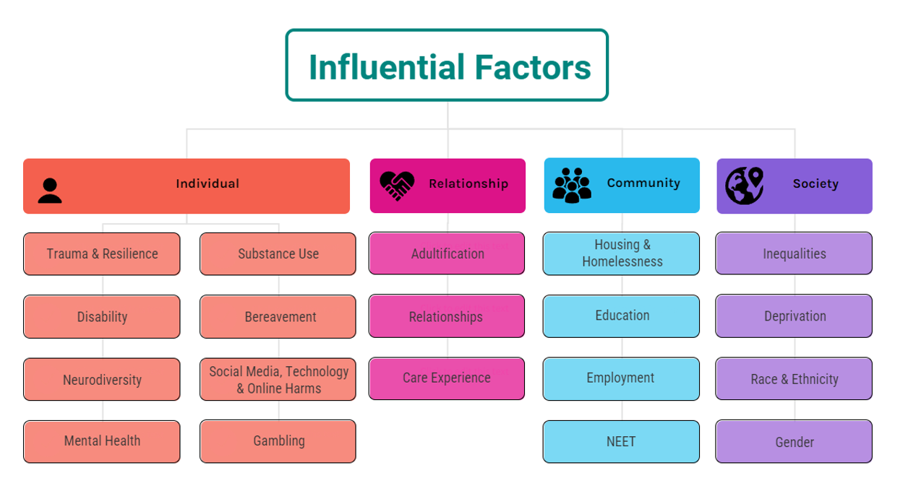
Some risk and protective factors can be conceptualised as being on different ends of the same continuum, for example unemployment has been identified as a risk factor for violence and conversely quality employment may be a protective factor against violence. It is important to note that neither risk or protective factors directly cause or prevent violence. Having a risk factor does not predict involvement in violence and it is not a predisposition, as such we refer to these collectively as influential factors for violence.

The VRP use the four-level socio-ecological model (individual, relationship, community, and societal) to better understand violence and the effect of potential prevention strategies. It allows an understanding of the range of factors that put people at risk for violence or protect them from experiencing or perpetrating violence. The ecological model emphasises that single risk factors do not directly cause violence, instead it is the interaction amongst different risk factors that influences the level of risk.

Key Findings

Children involved in serious violence
- Knife crime and robberies against children increased in Bradford, Kirklees, Leeds, and Wakefield.
- Calderdale experienced an increase in robberies against children.
- The proportion of assaults with intent to cause serious harm against children increased across West Yorkshire by 16%.
- 14-17 was a key age for children who were victims of assaults with intent to cause serious harm.
- Only 2 in every 1,000 children living in Calderdale, Leeds and Wakefield have committed violent crime.
- In Bradford and Kirklees this was 1 in every 1,000 children.
- When children do commit violent crime, this is starting as young as 11 in Bradford, Kirklees, and Wakefield, and as young as 10 in Calderdale and Leeds
- In West Yorkshire, this peaks between the ages of 12 to 17, but this varies between districts. This suggests there should be a focus on prevention prior to children moving to secondary school.
- There were 158 children who committed more than one violent crime in the 12 months – this equates to 22% of individuals being responsible for 46% of crime.
- 42% of this group had also committed violent crime in at least one of the previous 4 years, and 77% had also been a victim of violent crime in the 5-year period.

Other key findings
- Knife enabled assaults with intent to cause serious harm were at the lowest level for 5 years in all areas.
- Approximately half of adult offenders were recorded as being unemployed.
- Most people who committed violent crime were adult males; the proportion of men offending increased with the more serious offences.
- Rates of suspensions rose in 2021/22 across West Yorkshire. However, for autumn term 2022/23, these figures appear to be increasing in all areas but Wakefield, which is showing an improvement.
- Rates of severe absenteeism and unauthorised absence increased year on year from 2020/21 autumn and spring term to 2022/2023 autumn and spring term.

